HC-05 pinout, specifications, datasheet and HC05 Arduino connection

HC-05 Bluetooth module is a Bluetooth to serial converter that connects microcontrollers (like Arduino) to other Bluetooth enabled devices. HC-05 pinout and specifications are given b

Table Of Contents

1. [HC-05 Pinout with Description:](https://www.etechnophiles.com/hc-05-pinout-specifications-datasheet/#hc-05-pinout-with-description)
2. [HC-05 Specifications](https://www.etechnophiles.com/hc-05-pinout-specifications-datasheet/#hc-05-specifications)
3. [HC-05 Bluetooth module datasheet:](https://www.etechnophiles.com/hc-05-pinout-specifications-datasheet/#hc-05-bluetooth-module-datasheet)
4. [Introduction to HC-05 Bluetooth Module](https://www.etechnophiles.com/hc-05-pinout-specifications-datasheet/#introduction-to-hc-05-bluetooth-module)
5. [Working of HC-05 Bluetooth Module:](https://www.etechnophiles.com/hc-05-pinout-specifications-datasheet/#working-of-hc-05-bluetooth-module)
   * [Command Mode:](https://www.etechnophiles.com/hc-05-pinout-specifications-datasheet/#command-mode)
   * [Data Mode:](https://www.etechnophiles.com/hc-05-pinout-specifications-datasheet/#data-mode)
6. [HC-05 Breakout Board Pinout:](https://www.etechnophiles.com/hc-05-pinout-specifications-datasheet/#hc-05-breakout-board-pinout)
7. [Applications of HC-05 Bluetooth module:](https://www.etechnophiles.com/hc-05-pinout-specifications-datasheet/#applications-of-hc-05-bluetooth-module)

**HC-05 Pinout with Description:**

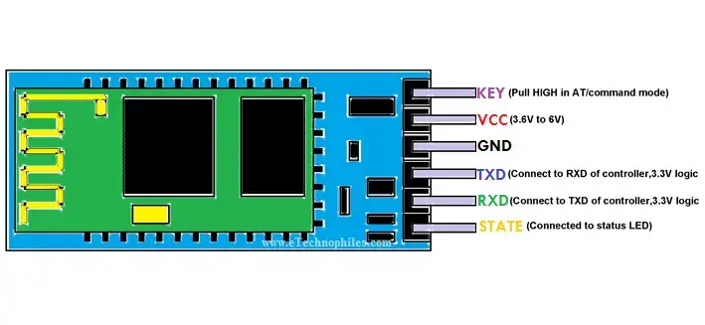

|  |  |  |
| --- | --- | --- |
| PIN NO. | Pin Name | Pin Description |
| 1. | **KEY/En** | This pin is used to bring the Bluetooth module in AT commands mode. By default, this pin operates in data mode. The Key/EN pin should be high to operate Bluetooth in command mode. In HC-05, the default baud speed in command mode is 38400bps and 9600 in data mode. |
| 2. | **VCC** | Used to power the Bluetooth module. Give 5V / 3.3 V to this Pin. |
| 3. | **GND** | The ground pin of the module |
| 4. | **TXD** | Connect this pin with the RXD pin of the Microcontroller. This pin transmits Serial data (wireless signals received by the Bluetooth module are converted by module and transmitted out serially on this pin) |
| 5. | **RXD** | Connect this pin to the TXD pin of the Microcontroller. The HC-05 Bluetooth module receives the data from this pin and then transmits it wirelessly. |
| 6. | **STATE** | It is used to check if the module is connected or not. It acts as a status indicator. |

## HC-05 Bluetooth****HC-05 Specifications****

* Bluetooth protocol: Bluetooth Specification **v2.0+EDR** (Enhanced Data Rate)
* Frequency: **2.4GHz ISM band**
* Modulation: **GFSK** (Gaussian Frequency Shift Keying)
* Emission power: ≤4dBm, Class 2
* Sensitivity: ≤-84dBm at 0.1% BER
* Speed: Asynchronous communication: **2.1Mbps (Max) / 160 kbps**, Synchronous communication: **1Mbps/1Mbps**
* Security: Authentication and encryption
* Profiles: Bluetooth serial port
* Supply Voltage: **+3.3V to 6.0 V**
* Supply Current: **30mA**
* Working temperature: -20 ~ +75Centigrade
* Dimension: **26.9mm x 13mm x 2.2 mm**
* HC-05 Bluetooth module follows the IEEE 802.15.1 standardized protocol, through which one can build a wireless Personal Area Network (PAN). It uses frequency-hopping spread spectrum (FHSS) radio technology to send data over the air.

## HC-05 Bluetooth module datasheet

Download the full datasheet from this link: [HC-05 Datasheet](https://www.etechnophiles.com/wp-content/uploads/2020/10/HC-05-Datasheet-Download.pdf)

## ****Introduction to HC-05 Bluetooth Module****

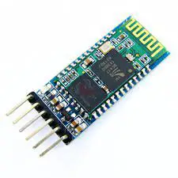The HC-05 is very easy to use Bluetooth to serial converter. HC-05 connects microcontrollers (like Arduino) to other Bluetooth enabled devices. This allows the devices to communicate wirelessly with each other.

HC-05 Bluetooth Module

HC-05 is a Bluetooth [SPP (Serial Port Protocol](https://en.wikipedia.org/wiki/Serial_port)) module designed for wireless communication. It can also be operated as a master or slave configuration.

## ****Working of HC-05 Bluetooth Module****:

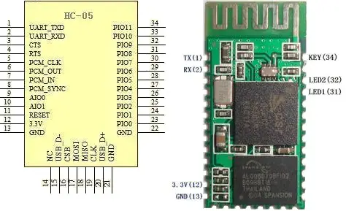The HC-05 Bluetooth Module can be used in two modes of operation: Command Mode and Data Mode.

### Command Mode:

In Command Mode, we can communicate with the Bluetooth module through AT Commands to configure various settings and parameters of the Module. This includes the firmware information, changing Baud Rate, changing module name, etc. We can also use it to set HC-05 as a master or slave. To select either of the modes, we need to activate the Command Mode and sent the correct AT Commands. Baud rate is **38400bps in command mode**.

* When we want to change settings of HC-05 Bluetooth module like change password for connection, baud rate, Bluetooth device’s name etc.
* To do this, HC-05 has AT commands.
* To use HC-05 Bluetooth module in AT command mode, connect “Key” pin to High (VCC).
* The default Baud rate of HC-05 in command mode is 38400bps.
* The following are some AT commands generally used to change setting of Bluetooth module.
* To send these commands, we must connect HC-05 Bluetooth module to the PC via serial to USB converter and transmit this command through serial terminal of PC.

|  |  |  |
| --- | --- | --- |
| **Command** | **Description** | **Response** |
| AT | Checking communication | OK |
| AT+PSWD=XXXX | Set Password  e.g., AT+PSWD=4567 | OK |
| AT+NAME=XXXX | Set Bluetooth Device Name  e.g., AT+NAME=MyHC-05 | OK |
| AT+UART=Baud rate, stop bit, parity bit | Change Baud rate.  e.g., AT+UART=9600,1,0 | OK |
| AT+VERSION? | Respond version no. of Bluetooth module | +Version: XX OK  e.g., +Version: 2.0 20130107   OK |
| AT+ORGL | Send detail of setting done by manufacturer | Parameters: device type, module mode, serial parameter, passkey, etc. |

### Data Mode:

In this mode, the module is used for communicating with other Bluetooth devices i.e. data transfer happens in this mode. Exchange of data between devices. Baud rate is 9600bps in data mode.

## ****HC-05 Breakout Board Pinout:****

|  |  |  |  |
| --- | --- | --- | --- |
| **PIN Name** | **Pin** | **Type** | **Description** |
| **GND** | 13,21,22 | VSS | Ground Pot |
| **3.3 VCC** | 12 | 3.3V | Integrated 3.3V supply with On-chip linear regulator output within 3.15-3.3V |
| **AIO0** | 9 | Bi-directional | Programmable input/output line |
| **AIO1** | 10 | Bi-directional | Programmable input/output line |
| **AIO0** | 23 | Bi-directional RX EN | Programmable input/output line, control output for LNA |
| **AIO1** | 24 | Bi-directional TX EN | Programmable input/output line, control output for PA |
| **PIO2** | 25 | Bi-directional | Programmable input/output line |
| **PIO3** | 26 | Bi-directional | Programmable input/output line |
| **PIO4** | 27 | Bi-directional | Programmable input/output line |
| **PIO5** | 28 | Bi-directional | Programmable input/output line |
| **PIO6** | 29 | Bi-directional | Programmable input/output line |
| **PIO7** | 30 | Bi-directional | Programmable input/output line |
| **PIN08** | 31 | Bi-directional | Programmable input/output line |
| **PIO9** | 32 | Bi-directional | Programmable input/output line |
| **PIO10** | 33 | Bi-directional | Programmable input/output line |
| **PIO11** | 34 | Bi-directional | Programmable input/output line |
| **RESET** | 11 | CMOS input with weak internal pull-up | Reset of low. Input debounced must be low for >5MS to cause a reset |
| **UART_RTS** | 4 | CMOS output, tri-stable with weak internal pull-up | UART request to send, active low |
| **UART_CTS** | 3 | CMOS input with weak internal pull-down | UART clear to send, active low |
| **UART_RX** | 2 | CMOS input with weak internal pull-down | UART Data input |
| **UART_TX** | 1 | CMOS output, tri-stable with weak internal pull-up | UART Data output |
| **SPI_MOSI** | 17 | CMOS input with weak internal pull-down | The Serial peripheral interface data input |
| **SPI_CSB** | 16 | CMOS input with weak internal pull-up | Chip select for the serial peripheral interface, active low |
| **SPI_CLK** | 19 | CMOS input with weak internal pull-down | The Serial peripheral interface clock |
| **SPI_MISO** | 18 | CMOS input with weak internal pull-down | The Serial peripheral interface data output |
| **USB_-** | 15 | Bi-directional |  |
| **USB_+** | 20 | Bi-directional |  |
| **NC** | 14 |  |  |
| **PCM_CLK** | 5 | Bi-directional | The Synchronous PCM data clock |
| **PCM_OUT** | 6 | CMOS output | The Synchronous PCM data output |
| **PCM_IN** | 7 | CMOS input | The Synchronous PCM data input |
| **PCM_SYNC** | 8 | Bi-directional | The Synchronous PCM data strobe |

**Applications of HC-05 Bluetooth module:**

* Computer and peripheral devices
* GPS receiver
* Industrial control
* MCU projects